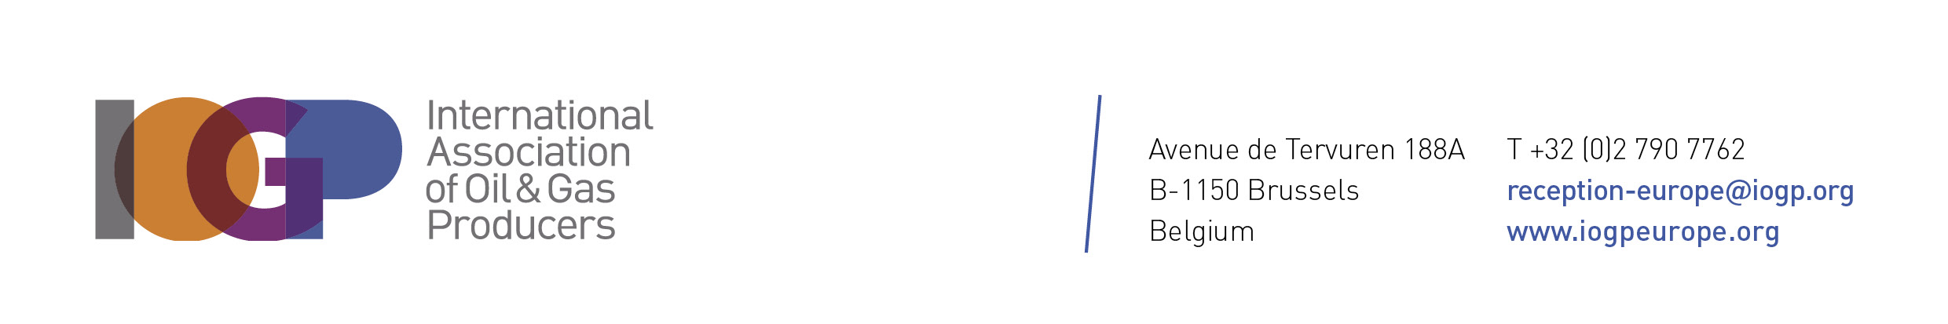
JOB DESCRIPTION

INTERNATIONAL ASSOCIATION of OIL & GAS PRODUCERS (IOGP) EUROPE

DEPARTMENT: Institutional Relations

JOB TITLE: (CIP or Intern) as Junior Institutional Relations Officer

REPORTING TO: Institutional Relations & Communications Manager

About us
IOGP Europe is the European advocacy arm of the International Association of Oil & Gas Producers (IOGP), the leading voice of the global oil and gas industry, pioneering excellence in safe, efficient and sustainable energy. We represent more than 30 energy companies accounting for 70% of EU oil & gas production. We support policymakers in crafting impactful and inclusive policies that drive prosperity for Europe’s industry in general, businesses and citizens.

IOGP Europe (Non profit organization) has a 20 people team working together in English/French in a dynamic, vibrant, diverse, international and enjoyable environment.
The team is organized in 4 areas:
- Policy: Energy and Climate/Environment & Sustainable Finance
- Institutional relations and outreach to the EU, Member states and third countries;
- Strategy and communications
- Administrative support

Position summary
We are recruiting a passionate, organized, and meticulous full-time junior institutional relations officer to join our Institutional relations team and provide comprehensive support in a variety of tasks related to administration, outreach and advocacy.

Scope, main purpose & objectives
- Assist with the preparation of briefing packs, meeting materials and background documents; take notes and follow up on action points;
- Provide day-to-day administrative support to the Institutional Relations team, including preparing and updating PowerPoint presentations, Excel trackers, contact lists and internal documents;
- Support meeting and travel arrangements, including scheduling, registrations, bookings, agendas and practical logistics;
- Maintain and update stakeholder databases, mailing lists, meeting records and institutional contact information;
- Support the organisation of meetings, events and institutional visits, including invitations, participant tracking and logistics;
- Monitor selected EU institutional and legislative developments and provide short internal updates;
- Conduct stakeholder mapping and research on EU institutions, Member States and relevant third countries;
- Support engagement with the European Parliament, European Commission and Council, including coordination with MEP offices and other institutional contacts;
- Contribute, under the guidance of the Institutional Relations team, to IOGP Europe’s outreach and advocacy activities.

Qualifications & experience
- Proficient in database management and Microsoft 365, with strong skills in Excel, PowerPoint, and Outlook;
- Fluent in English and strong knowledge of at least one other European language;
- License and/or Master’s Degree in European or Public Affairs, Political Science, International Relations or equivalent;
- Outcome-driven and solution-oriented attitude;
- Adaptable, comfortable working in a very fast-paced environment and able to re-prioritize on the go;
- Ability to run multiple projects simultaneously;
- Good understanding of EU policymaking dynamics and processes;
- Ability to contribute innovative ideas regarding the outreach to the EU Institutions
- Solid research, analytical and IT;
- Experience in EU Public Affairs, including traineeship / Blue books in the European institutions or in other trade associations is a plus.

Knowledge & attributes
- Proactive mindset, capable of identifying and resolving potential challenges before they escalate, while diplomatically managing complex situations;
- Strong team spirit, working in solidarity, and a collegial approach to decision-making
- Ability to help overcome differences and reach a compromise;
- Strong communication skills;
- Apply a solution oriented mindset in stressful and uncertain situations;
- Good knowledge of sustainability, energy, and climate issues; familiarity with the oil & gas industry is an advantage;
- Open to travel and flexibility to occasionally work outside regular office hours.

What we offer
- A role designed to provide valuable professional experience and a strong foundation for the next step of your career, whether in European institutions, public affairs, trade associations or the wider energy sector;
- A young, dynamic, international and collaborative team environment;
- The opportunity to build a broad network across the EU institutions, energy sector and wider Brussels public-affairs community with career grow opportunities whether in IOGP Europe or within the EU Bubble;
- A €1,700 (net) monthly CIP allowance, together with a comprehensive package of benefits including meal vouchers, a monthly MOBIB public transport pass, mobile phone plan, laptop and free access to the fitness facilities in our office;
- A six-month contract, with the possibility of renewal up to 1 year.

If you think that you want be part of this passionate and friendly team, please send your resume with a cover letter to show your motivations to:
recruitment-europe@iogp.org

