IOGP welcomes ROMGAZ

IOGP is delighted to welcome Europe’s third largest producer, ROMGAZ, as its newest Member.
This integrated regional operator accounts for 40% of the total natural gas consumption in Romania.
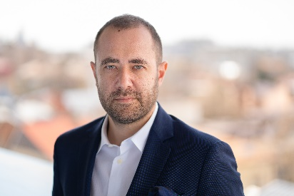
ROMGAZ CEO, Răzvan Popescu, will serve as Member Representative to the IOGP.
“ROMGAZ values IOGP’s work as an enabling partner for a low carbon future and solution provider for the challenges facing our industry,” says Răzvan. “ROMGAZ particularly appreciates IOGP’s advocacy work in promoting the gas industry’s contribution to the EU economy, whilst helping it reach its 2050 climate neutrality objective, and looks forward to playing an active role in this area.”
"We are delighted and proud to welcome ROMGAZ into the IOGP,” says François-Régis Mouton, Managing Director - IOGP Europe. “As one of the largest producers in Europe with great potential, ROMGAZ brings a wealth of expertise, innovation, and commitment to advancing sustainability practices within the energy industry, while increasing EU domestic gas production and therefore the security of energy supplies. We look forward to working with Răzvan Popescu and his team, fostering collaboration, and shaping the future of responsible and resilient energy exploration and production."

